**Turf Equipment Utilization Dashboard Using Power BI**

**Submitted by**

**SRI RAGHAVARDHINI M (Reg.No:24MCR107_)**

***In partial fulfilment of the requirements for award of the degree of***

**MASTER OF COMPUTER APPLICATIONS IN**

**DEPARTMENT OF COMPUTER APPLICATIONS KONGU ENGINEERING COLLEGE**

**(Autonomous) PERUNDURAI, ERODE – 638 060**



**DECEMBER 2024**

# Abstract

The effective management and utilization of turf equipment is critical for operations such as landscaping, golf courses, sports fields, and large-scale agricultural fields. Power BI provides a robust platform for developing a comprehensive “Turf Equipment Utilization Dashboard”, enabling stakeholders to monitor equipment performance, operator efficiency, fuel consumption, and maintenance schedules.

This project demonstrates a step-by-step approach to creating such a dashboard using Power BI's “Power Query Editor” for data transformation. The dataset includes key variables like equipment type, operator data, usage time, fuel consumption, and maintenance logs. The process includes loading the dataset, cleaning and transforming the data, creating calculated fields (e.g., usage duration), and visualizing key insights through bar charts, line charts, pie charts, and gauge charts.

Through Power Query’s ability to filter, group, and aggregate data, this project allows managers to track equipment usage patterns, optimize operator performance, reduce fuel wastage, and prevent costly breakdowns by scheduling timely maintenance. The dashboard offers real-time insights into fleet utilization and promotes data-driven decision-making. With an automated data refresh schedule, this solution can be continuously updated to ensure the most accurate operational view.

This abstract highlights the role of Power BI and Power Query in providing a scalable solution for effective equipment monitoring, ensuring operational efficiency and cost savings in turf management operations.

# Problem Statement

Managing and optimizing the utilization of turf equipment in large-scale operations such as golf courses, sports fields, and agricultural fields presents significant challenges. Equipment downtime, inefficient fuel consumption, operator performance variability, and unscheduled maintenance often lead to operational inefficiencies, increased costs, and reduced equipment lifespan. Without a robust system to monitor and analyze equipment usage and maintenance needs, organizations struggle to make data-driven decisions that can improve overall performance and reduce costs.

The key challenges include:

- Lack of real-time visibility into equipment usage, leading to underutilization or overuse of specific machinery.

- Difficulty in tracking and optimizing fuel consumption across multiple pieces of equipment.

- Inconsistent maintenance scheduling, resulting in equipment breakdowns and costly repairs.

- Inefficient operator performance management due to the absence of consolidated data on equipment usage across different locations and operators.

To address these issues, a comprehensive “Turf Equipment Utilization Dashboard” is needed to monitor equipment activity, track fuel consumption, ensure timely maintenance, and assess operator efficiency in real time. This dashboard will provide actionable insights into operational performance, enabling organizations to optimize equipment usage, reduce costs, and extend the lifespan of their machinery. The solution will also streamline maintenance management and improve decision-making based on accurate and timely data.

# Approach

The development of a “Turf Equipment Utilization Dashboard” using Power BI involves several key steps, ranging from data acquisition and transformation to dashboard creation and visualization. The approach can be broken down into the following phases:

1. Data Collection and Structuring

“Identify Key Data Sources”: Collect data from various sources such as equipment usage logs, operator records, maintenance logs, and fuel consumption data. This could involve Excel files, CSV files, or integration with an equipment management system.

Define Key Metrics: Identify the critical metrics to track, including:

Equipment usage duration (start and end times).

Fuel consumption for each piece of equipment.

Operator performance (equipment handled and hours logged).

Maintenance schedules and history.

Location-specific equipment usage.

Prepare a Data Schema: Organize the dataset to ensure all necessary fields (Equipment ID, Operator ID, Fuel Consumption, Start/End Time, etc.) are present and structured properly for analysis.

2.Data Loading into Power BI

Import the Dataset: Load the prepared dataset (e.g., Excel or CSV files) into Power BI using the **Get Data** feature.

Verify Data Integrity: Ensure that all data is loaded correctly and matches the predefined schema. Check for missing data, duplicates, or any inconsistencies that might affect the analysis.

3.Data Transformation Using Power Query

Data Cleansing: Clean and refine the data using Power Query by removing unnecessary columns, renaming fields, and correcting data types (e.g., converting dates to the correct format).

Create Calculated Columns:

Calculate Usage Duration by subtracting the start time from the end time.

Create flags for Maintenance Requirements to differentiate between equipment that needs servicing and those that don't.

Extract date parts (e.g., day, week, month) for time-based analysis.

Group and Aggregate Data: Use the Group By function to calculate total equipment usage per week, month, or operator, and sum fuel consumption for each piece of equipment or location.

4. Dashboard and Visualization Design

Design the Layout: Sketch the desired dashboard layout, focusing on clear, insightful visualizations that represent the key metrics.

Create Visualizations:

Use a Line Chart to display equipment usage trends over time.

Use a Clustered Bar Chart to show the most-used equipment based on total hours logged.

Use a Gauge Chart for monitoring total fuel consumption compared to a predefined threshold.

Use a Pie Chart to display the percentage of equipment that requires maintenance.

Add Slicers: Include slicers for Equipment Type, Operator, and Date to allow users to filter the data dynamically.

5. Analysis and Insights Generation

Usage Patterns: Analyze the data to identify equipment that is underutilized or overutilized and make recommendations for optimizing usage.

Fuel Efficiency: Highlight equipment that consumes excessive fuel and identify potential causes, such as operator inefficiency or equipment wear.

Maintenance Forecasting: Analyze the maintenance data to schedule preventive maintenance, reducing downtime and improving equipment longevity.

Operator Performance: Evaluate operator performance based on the hours logged and fuel used, enabling improved training or reassignment of tasks.

6.Optimization and Interactivity

Interactive Filters and Drill-Downs: Ensure the dashboard allows users to interactively explore the data by drilling down into specific equipment types, operators, or time periods.

Data Refresh and Automation: Set up automated data refresh schedules for regular updates to ensure the dashboard reflects real-time operations.

7. Publishing and Sharing

Publish the Dashboard: Once finalized, publish the dashboard to the Power BI Service to share with stakeholders and decision-makers.

User Access and Reports: Ensure the right users have access to the reports, and create alerts or scheduled reports to notify stakeholders of key changes (e.g., when equipment needs maintenance).

8. Continuous Monitoring and Improvement

Feedback and Iteration: Gather feedback from stakeholders and continuously improve the dashboard by adding new data fields or visualizations as needed.

Scalability: Plan for scaling the dashboard to accommodate additional equipment, operators, or new types of data (e.g., equipment sensor data).

**INDEX**

|  |  |  |
| --- | --- | --- |
| **Sno** | **Title Of Experiment** | **Page No** |
| 01. | IMPORT DATA INTO POWER BI DESKTOP AND PERFORM  BASIC OPERATIONS |  |
| 02. | DEVELOP DATA MODEL FOR THE GIVEN |  |
| 03. | CREATE SIMPLE CHARTS AND GRAPHS |  |
| 04. | CREATE AND PUBLISH POWER BI REPORTS |  |
| 05. | CREATE POWER BI DASHBOARDS |  |
| 06. | CREATE A STACKED BARCHART |  |
| 07. | APPLY FILTERS IN THE REPORT |  |
| 08. | CONNECT POWER BI DESKTOP WITH POWER BI SERVICES |  |
| 09. | CREATE A MAP IN POWER BI |  |
| 10. | CREATE AND FORMAT A SLICER IN POWER |  |
| 11. | DEMONSTRATE BASIC OPERATION USING |  |
| 12. | PERFORM DATA ANALYTICS WITH PIVOT |  |

|  |  |
| --- | --- |
| Ex No : 01 | **IMPORT DATA INTO POWER BI DESKTOP AND PERFORM BASIC OPERATIONS** |
| Date: |

**IMPORT DATA INTO POWERBI DESKTOP**

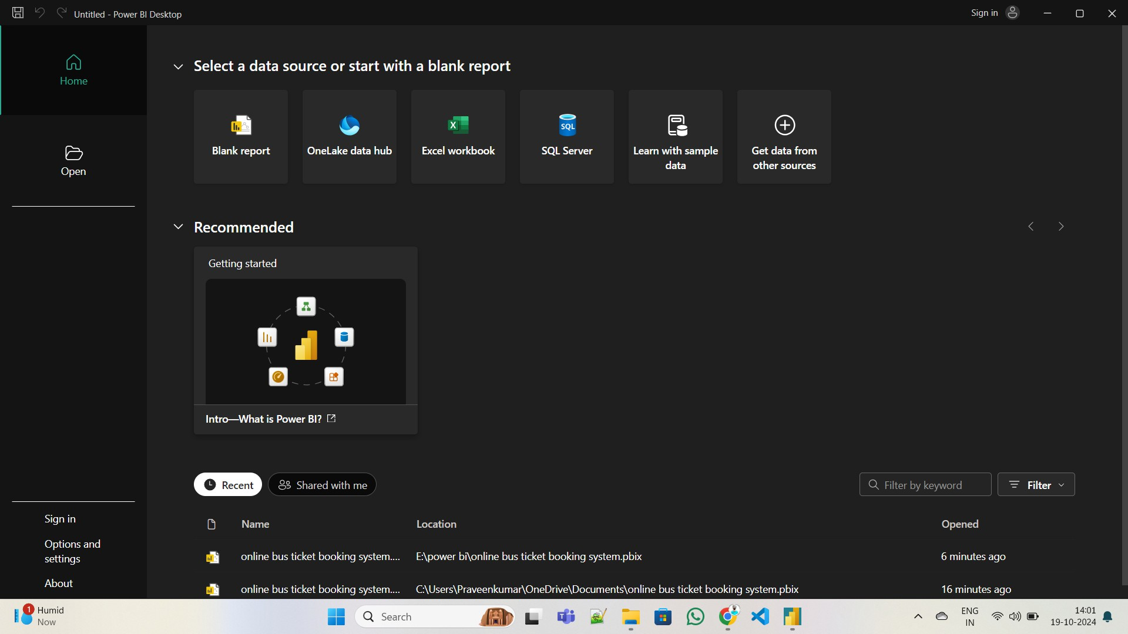

**GET DATA as a Excel FILE**

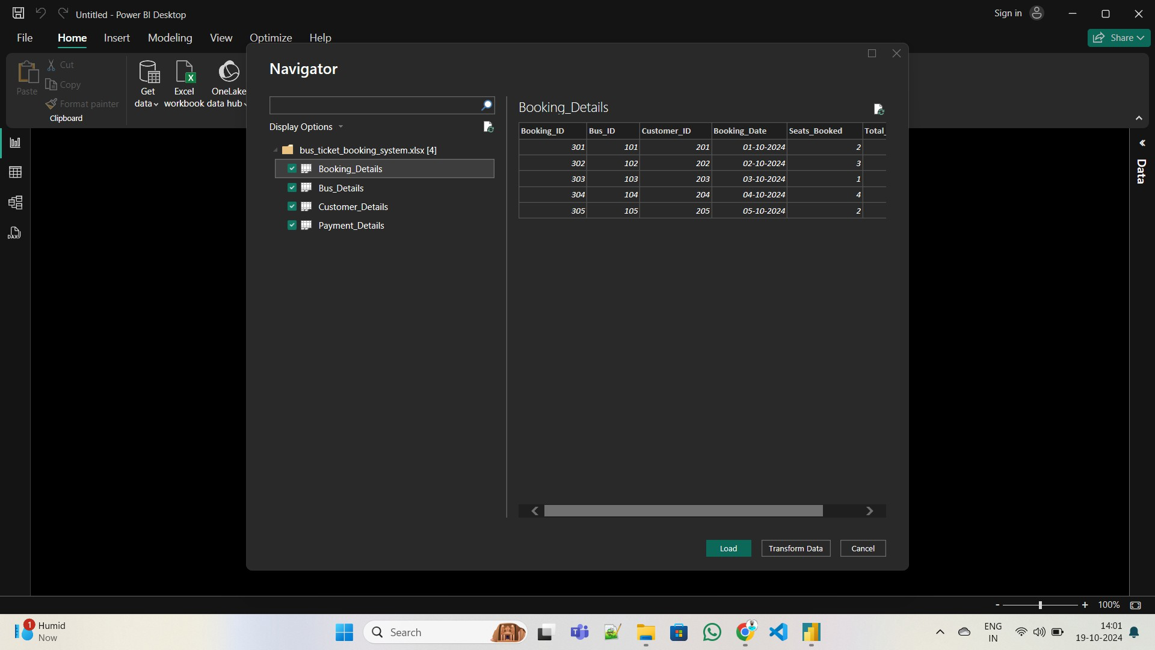

**LOAD DATA(Online bus ticket booking system.xlsx)**

## BASIC OPERATIONS

CREATE VISUALIZATION

1. Create a Chart

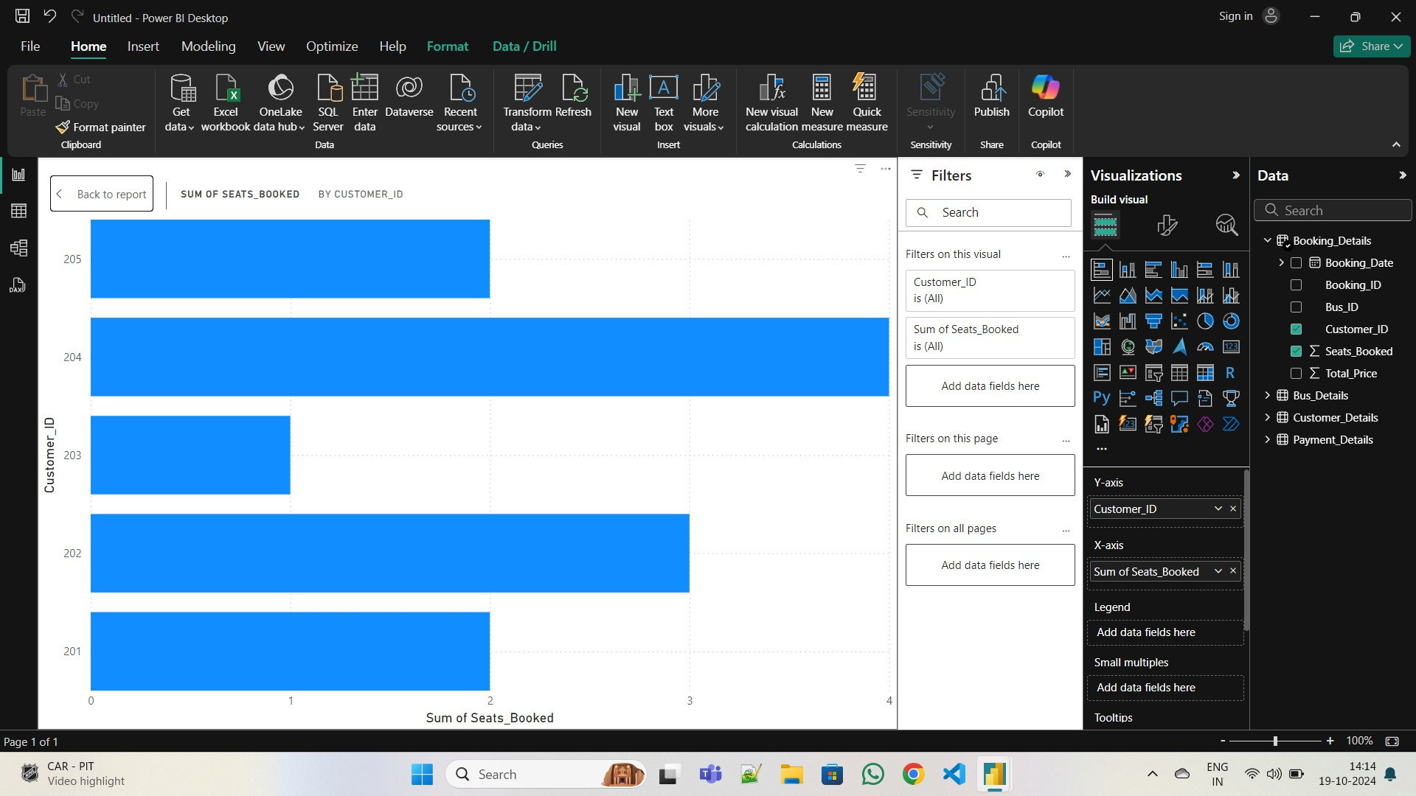

1. Create a table

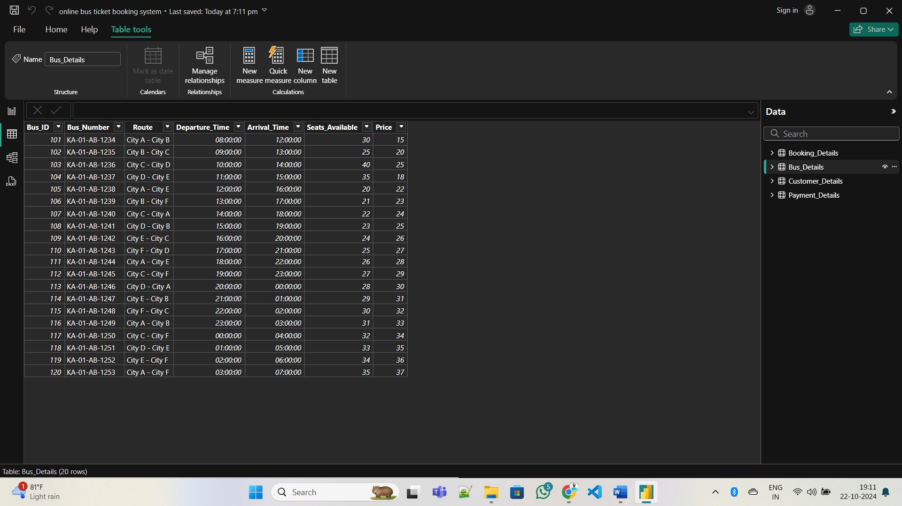

|  |  |
| --- | --- |
| Ex No : 02 | **DEVELOP DATA MODEL FOR THE GIVEN PROBLEM** |
| Date: |

1. **Identify Key Entities and Tables**

The first step in developing a data model is identifying the key entities involved in the project. For this Online Bus Ticket Booking System Using Power BI.

* 1. **Seats Booked**
  2. **Price**
  3. **Seats Available**
  4. **Payment ID**
  5. **Total Price**

Each entity will have its own table, and there will be relationships between them.

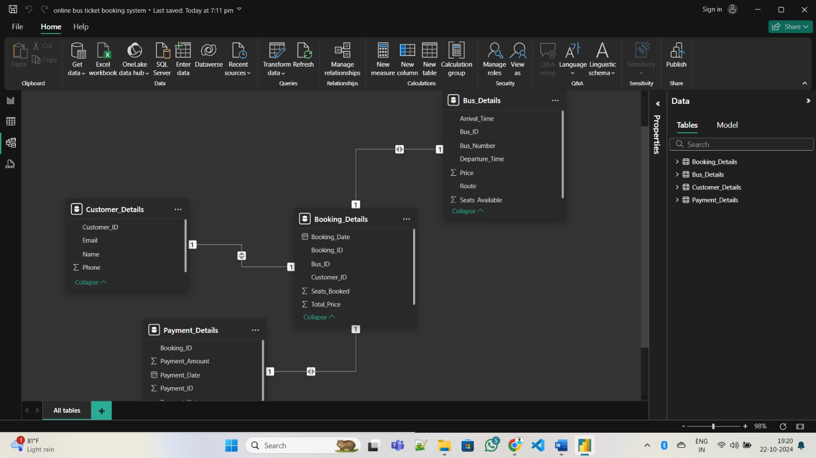

**Model View**

|  |  |
| --- | --- |
| Ex No : 03 | **CREATE SIMPLE CHARTS AND GRAPHS** |
| Date: |

LINE AND CLUSTERED COLUMN CHART

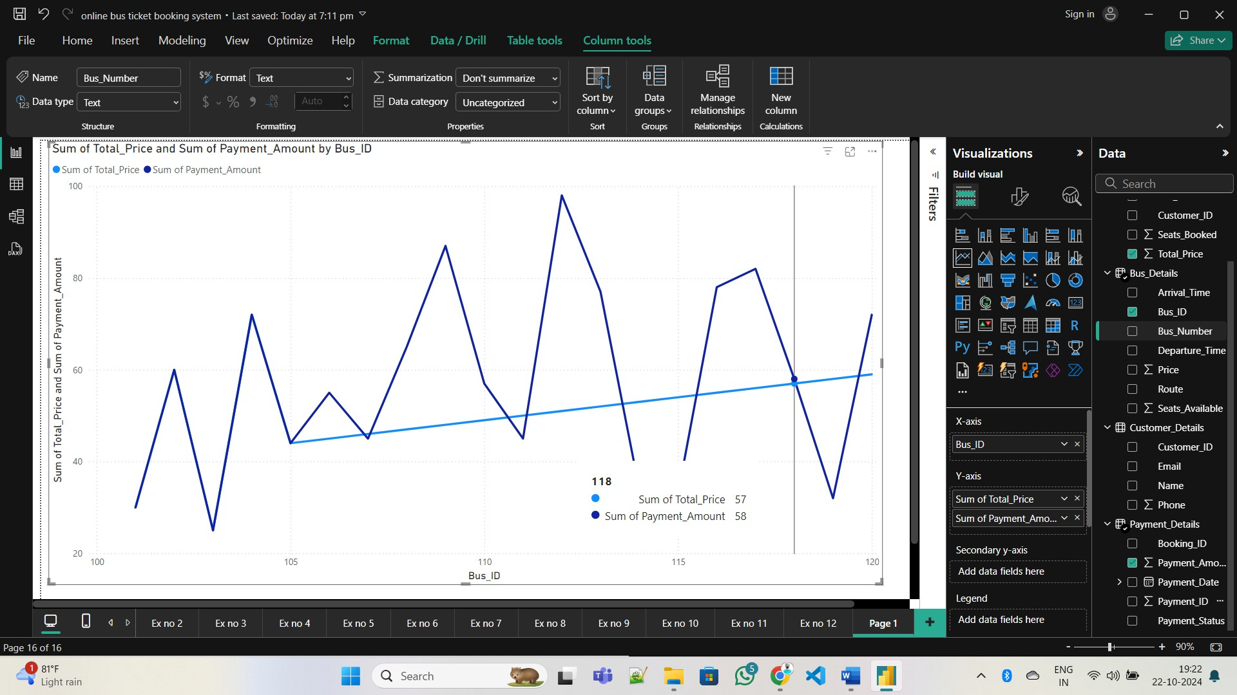

LINE CHART

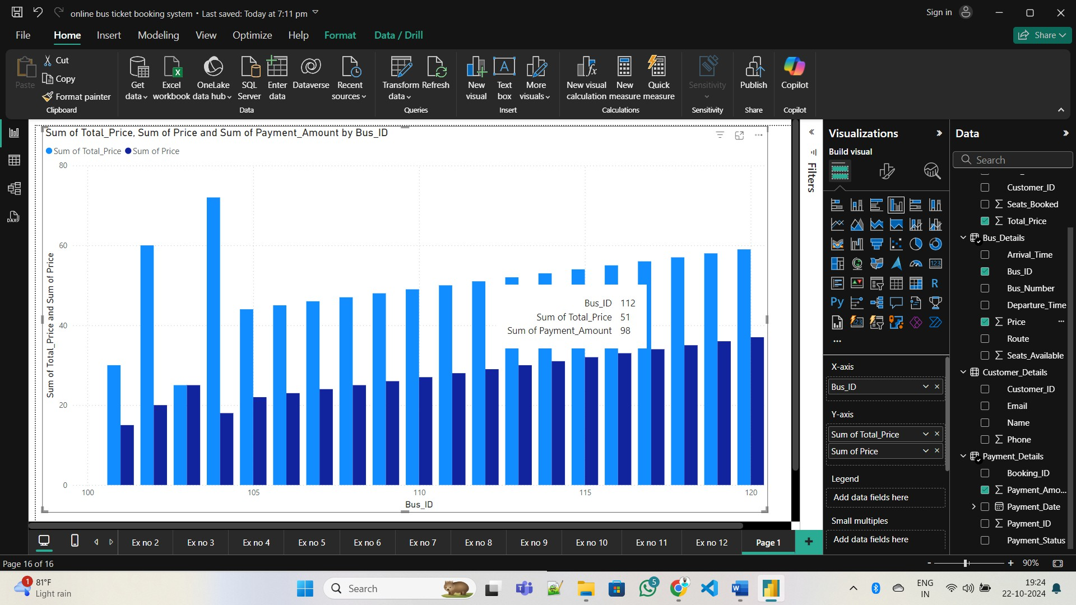

|  |  |
| --- | --- |
| Ex No : 04 | **CREATE AND PUBLISH POWER BI REPORTS** |
| Date: |

CREATING REPORT

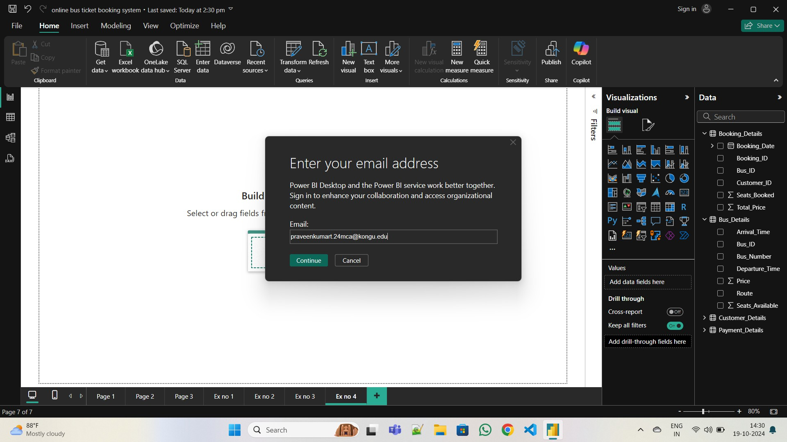

**Creating Report**

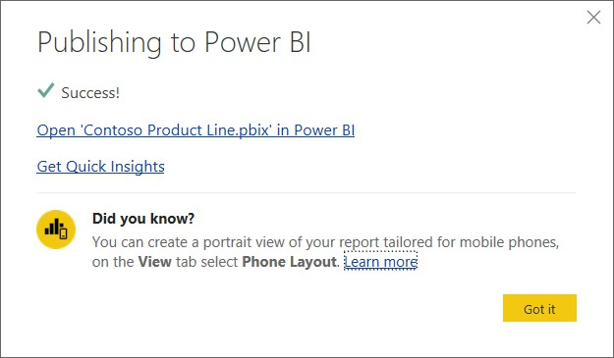

**Publish Report**

|  |  |
| --- | --- |
| Ex No : 05 | **CREATE POWER BI DASHBOARDS** |
| Date: |

Load Dataset:

Import competition data into Power BI and set up relationships between tables (e.g., Participants, Competitions).

Create Visuals:

Design charts, tables, and KPIs to display key metrics like participation, prizes, and competition types.

Customize Layout:

Format visuals with titles, data labels, and arrange them for a clear, organized view. Publish and Share: Publish the report to Power BI Service, pin key visuals to a dashboard, and share with stakeholders.

Review and Adjust:

Ensure interactivity with filters and drill-through features, allowing users to explore the data dynamically.

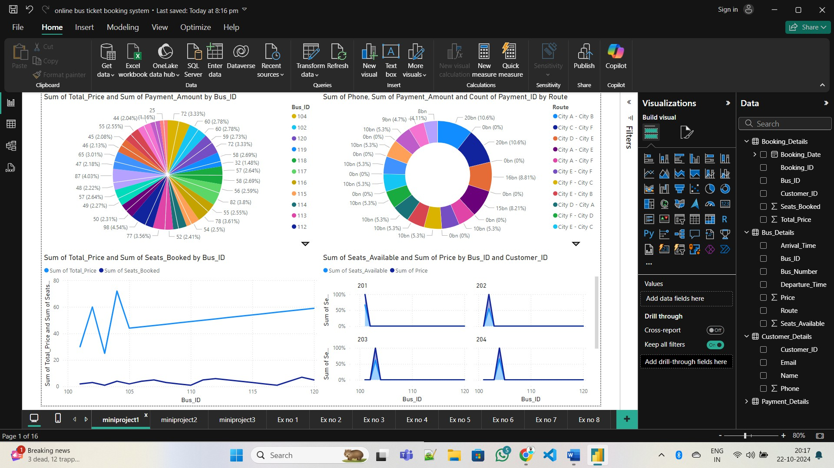

**Dashboard**

|  |  |
| --- | --- |
| Ex No : 06 | **CREATE A STACKED BARCHART** |
| Date: |

1. **Data Preparation**:

Ensure your dataset includes relevant fields such as Communication Type, Engagement, Event Attendance, and Donation Amount.

1. **Visualization**:

Select the "Stacked Bar Chart" from the Visualizations pane.

1. **Axes Setup**:

Drag the **Communication Type** to the X-axis and **Engagement** (e.g., Opened, Replied) to the Y- axis.

1. **Stacking by Engagement**:

Add **Engagement** to the Legend to stack bars by different engagement types.

1. **Filter by Event Attendance**:

Use filters for **Event Booking id** or **Customer id** to focus on specific segments of alumni behavior.

1. **Formatting**:

Customize colors, labels, and tooltips to enhance readability.

1. **Interpretation**:

The stacked bar chart will help visualize alumni engagement across different communication types.

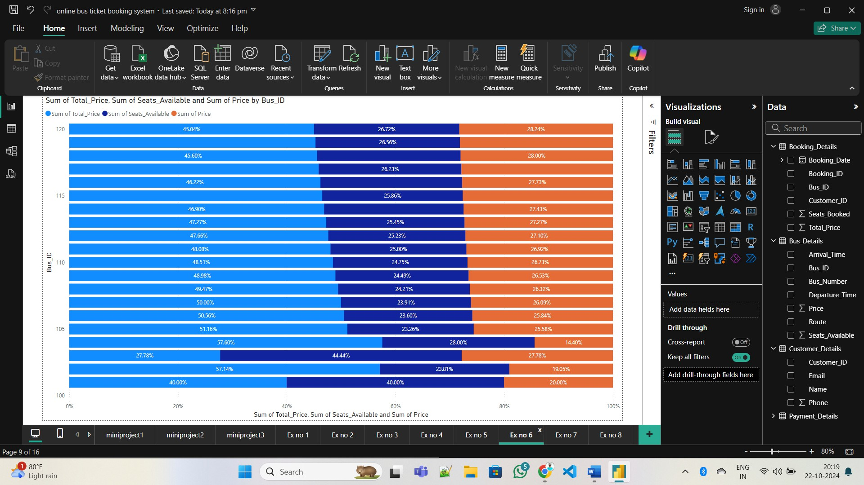

**Stacked Barchart**

|  |  |
| --- | --- |
| Ex No : 07 | **APPLY FILTERS IN THE REPORT** |
| Date: |

On the right side of the screen, you’ll find the **Filters Pane** under the **Visualizations Pane**. This pane allows to apply filters at different levels**: visual, page**, or **report.**

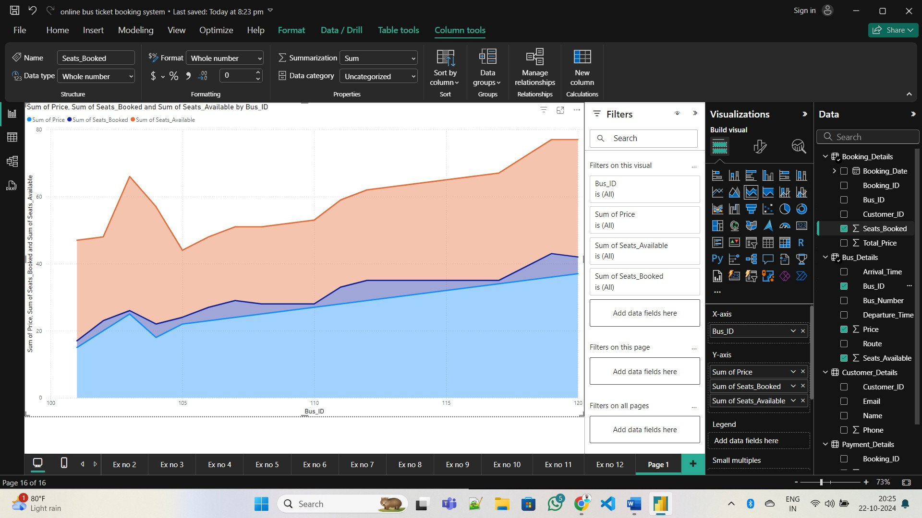

Before filtering

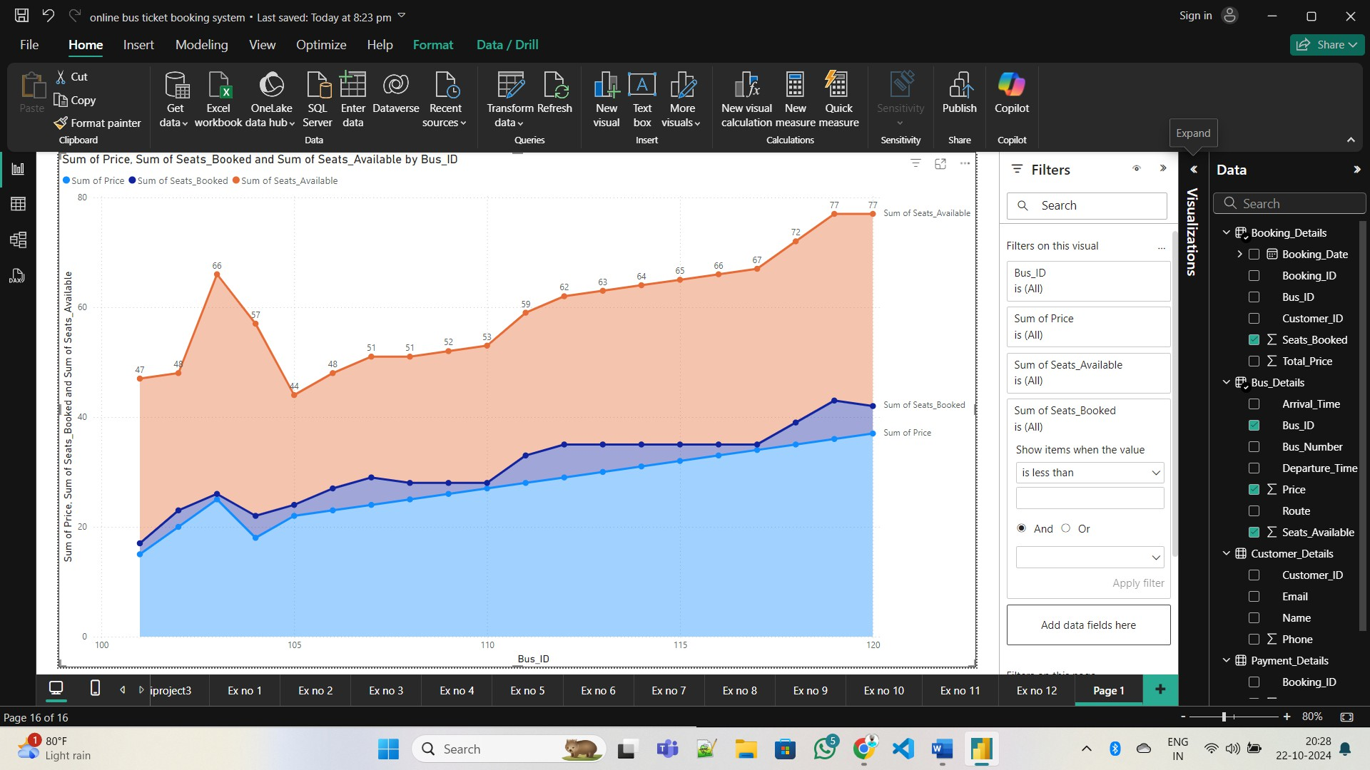

After Filtering

|  |  |
| --- | --- |
| Ex No : 08 | **CONNECT POWER BI DESKTOP WITH POWER BI SERVICES** |
| Date: |

1. **Sign in** to Power BI Desktop using your Power BI Service account.
2. **Publish the report** by clicking the **Publish** button in Power BI Desktop and selecting a Workspace.
3. After publishing, **view your report** on Power BI Service by logging in at app.powerbi.com.
4. Optionally, set up a **data refresh schedule** for automatic updates.
5. **Share the report** with others by using the Share button in Power BI Service.

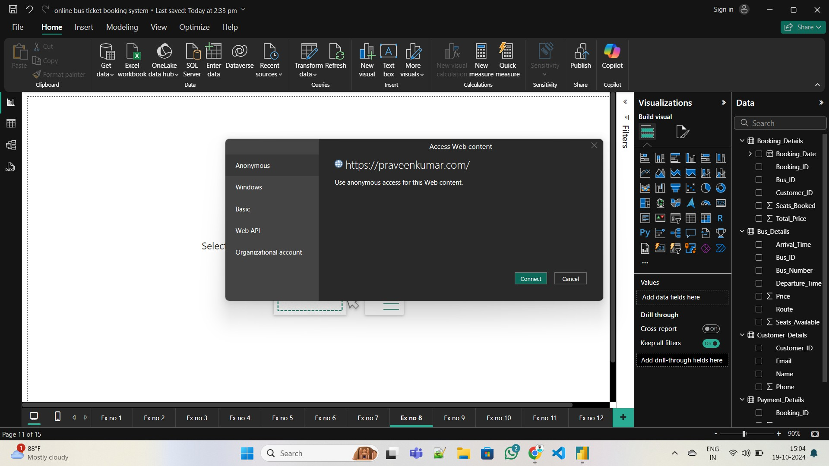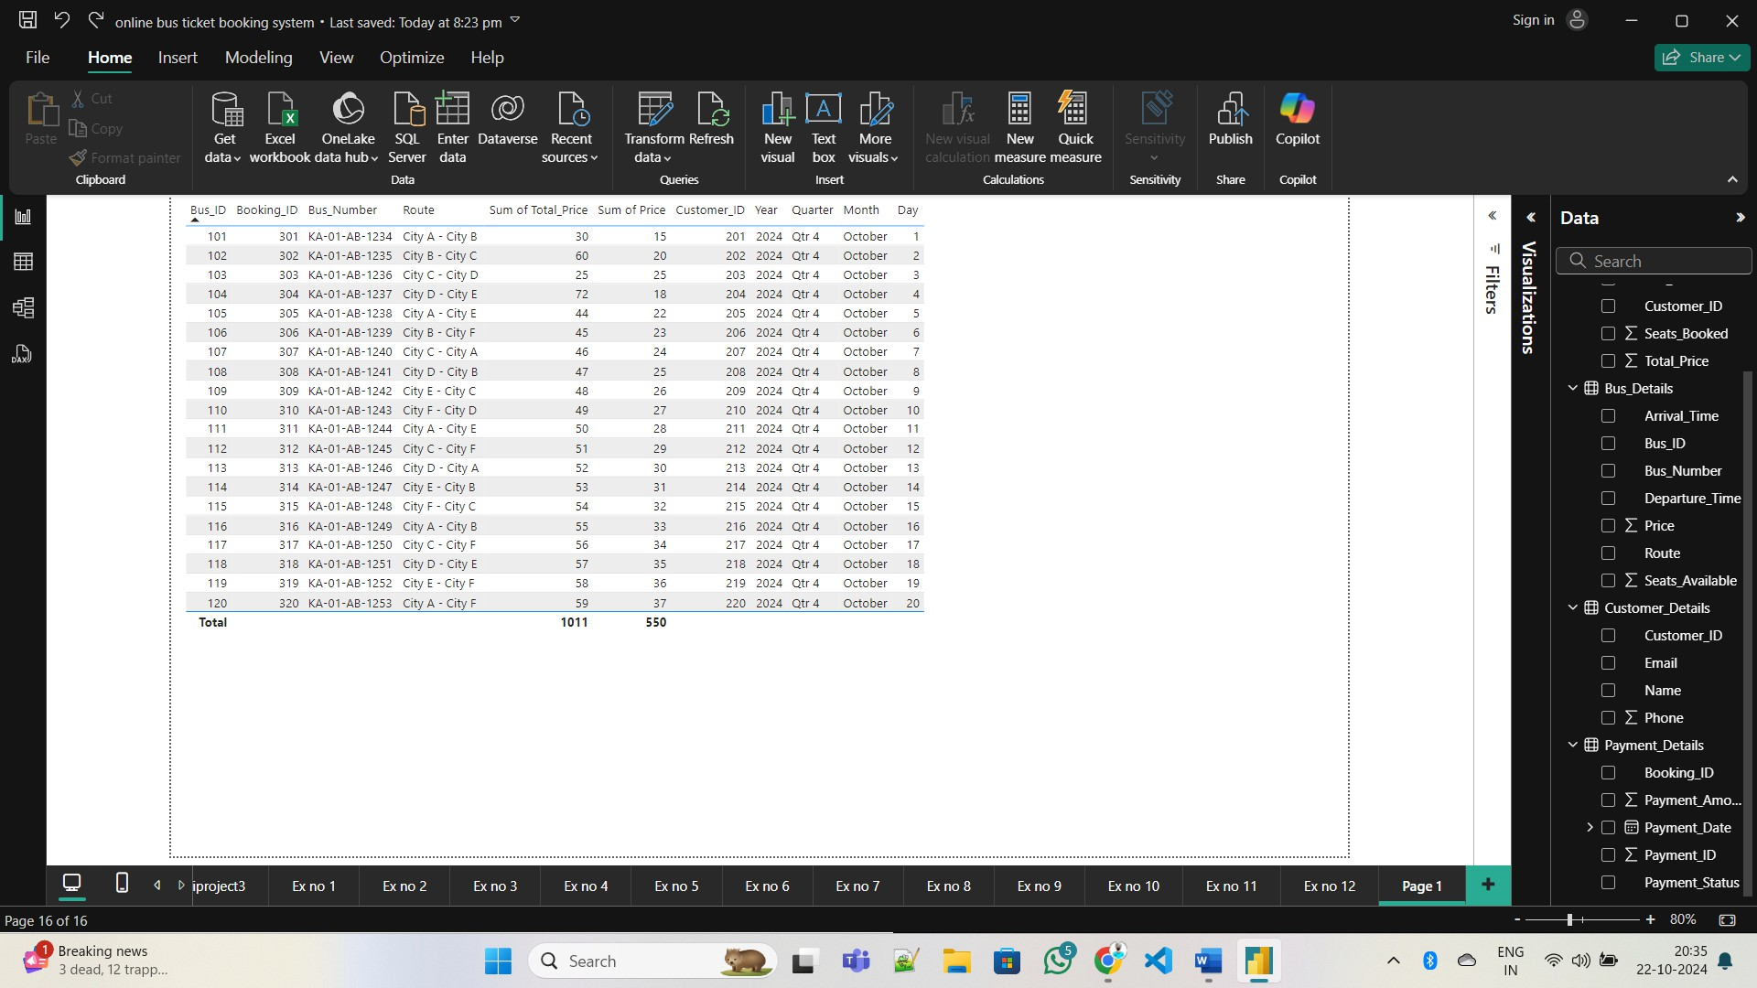

|  |  |
| --- | --- |
| Ex No : 09 | **CREATE A MAP IN POWER BI** |
| Date: |

**Steps to Create a Map in Power BI:**

* 1. **Data Preparation**: Ensure your dataset contains **City** and **Country** fields to map alumni locations geographically.
  2. **Visualization Selection**:
     + In Power BI, go to the **Visualizations** pane.
     + Choose the **Map** visual (globe icon) for a standard map, or select **Filled Map** to show regions.
  3. **Configure Map Fields**:
     + **Location Field**: Drag the **City** or **Country** field into the **Location** area of the Map visual.
     + **Size Field**: Optionally, add **Booking id** or **Customer id** into the **Size** area, so larger donations or participation are represented by larger data points.
  4. **Customize Tooltip**:
     + Drag additional fields such as **Full Name**, **Graduation Year**, or **Engagement** into the **Tooltip** area. These will appear when you hover over a location on the map.
  5. **Adjust Formatting**:
     + Use the **Format** pane to adjust map settings, such as bubble size, map background, and zoom level.

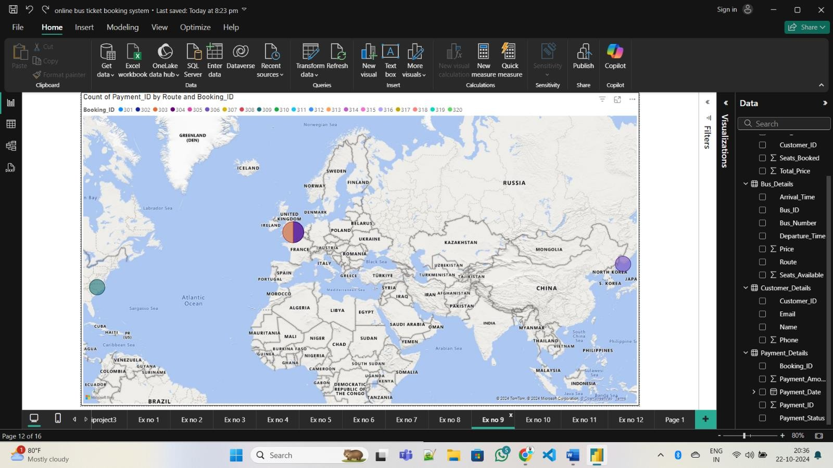

|  |  |
| --- | --- |
| Ex No : 10 | **CREATE AND FORMAT A SLICER IN POWER BI** |
| Date: |  |

Open Power BI Desktop, load your dataset, and select the **Slicer** visual from the **Visualizations pane**. Drag and drop the desired field (e.g., "Bus_id") into the slicer visual.

Adjust the slicer settings in the **Visualizations** pane for single or multi-select options. Use the **Format** pane to customize the title, font, colors, and layout of the slicer.

Test the slicer by clicking on items to filter other visuals, and then save your report.

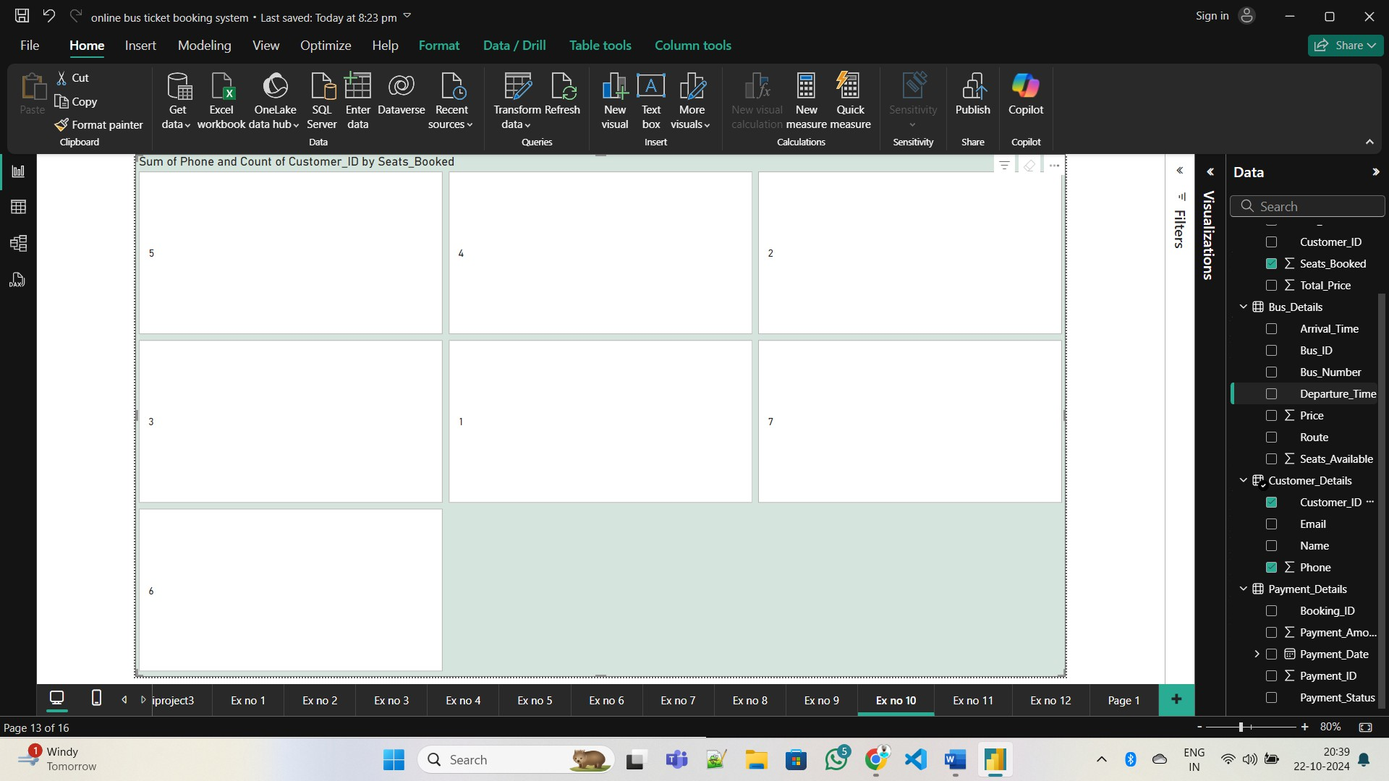

Slicer

|  |  |
| --- | --- |
| Ex No : 11 | **DEMONSTRATE BASIC OPERATION USING POWER PIVOT IN EXCEL** |
| Date: |

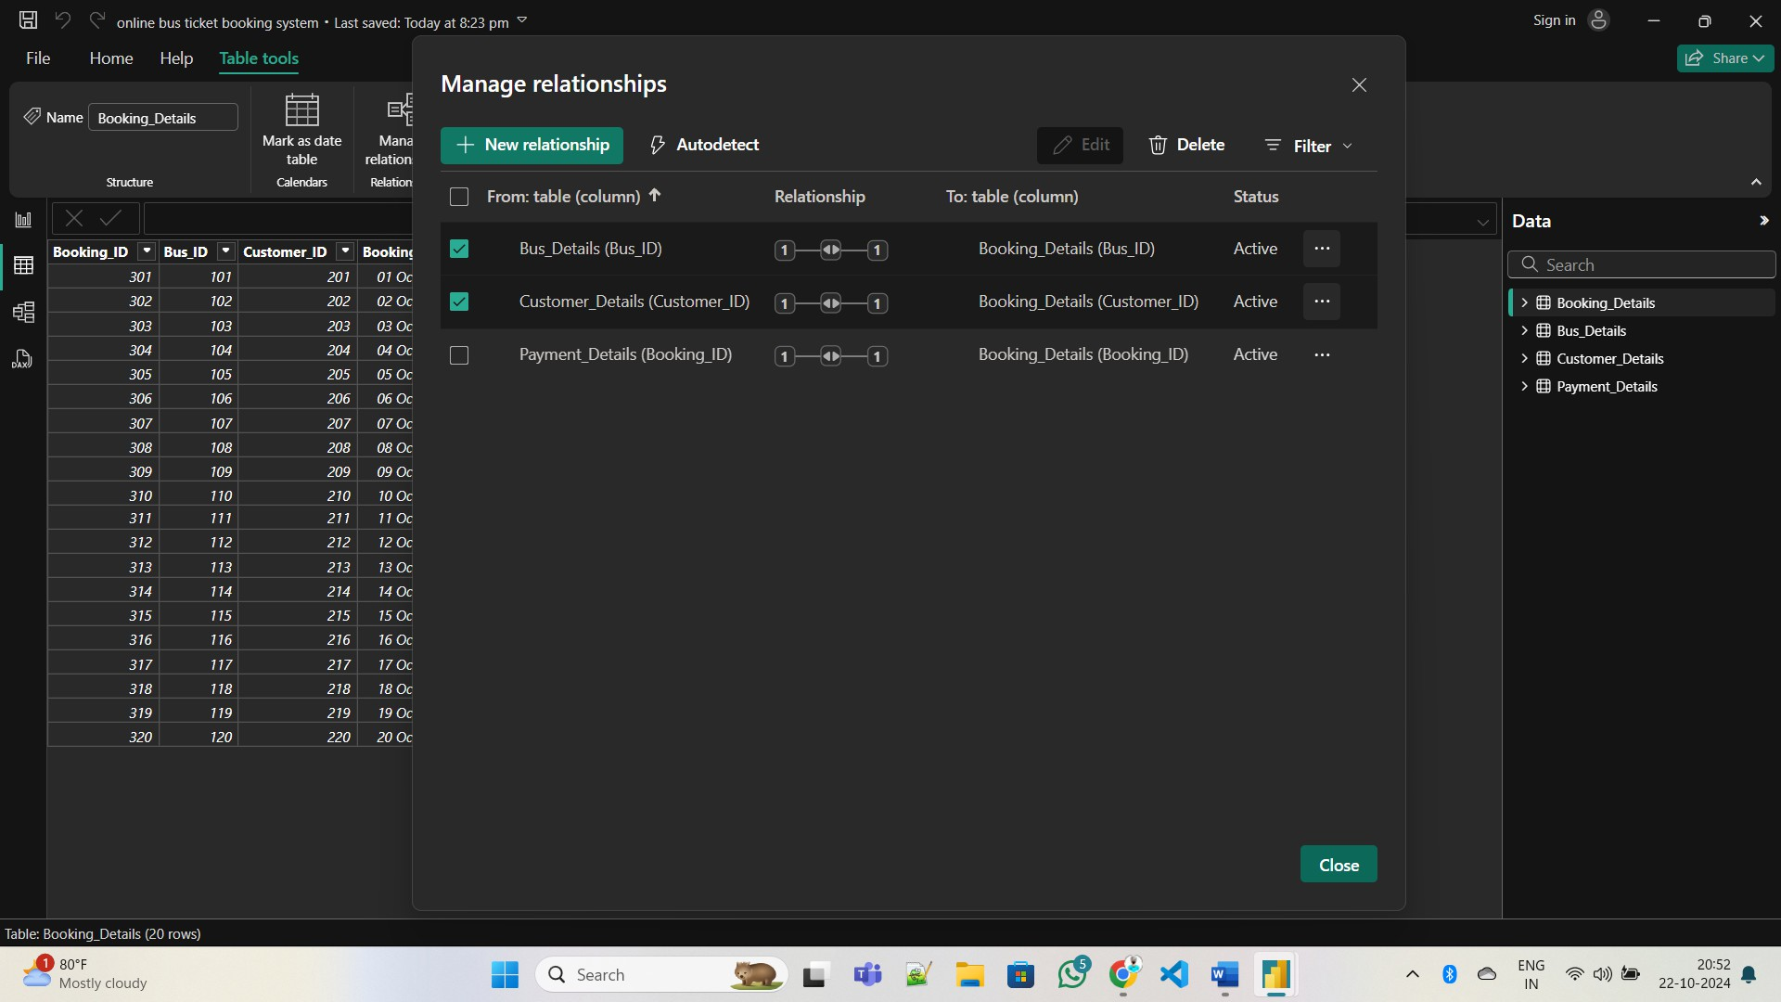

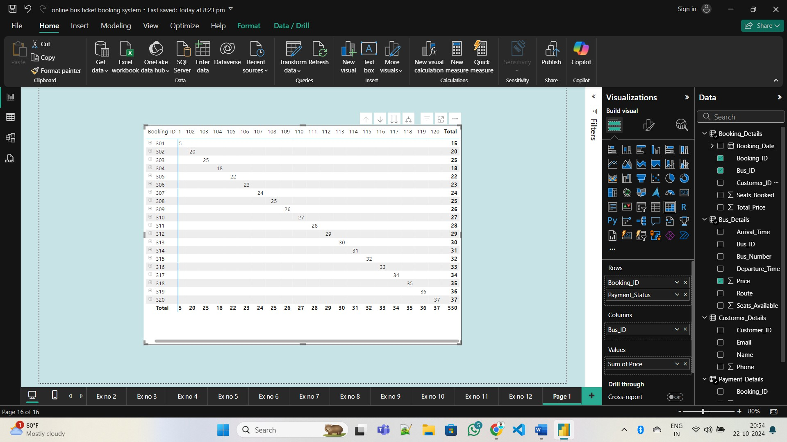

|  |  |
| --- | --- |
| Ex No : 12 | **PERFORM DATA ANALYTICS WITH PIVOT TABLE AND CHARTS** |
| Date: |

